**Procedure for CC studio V3.1**

1. On desktop double click on icon setup CC studio V3.1.

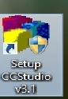

2. One window will open with 3 column.

a) 1st column My system

b) 2nd Column processor selection

c) 3rd column description about the processor

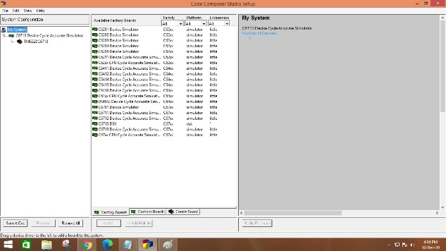

3. In the 1st column, under My system right click and remove the processor, click Yes.

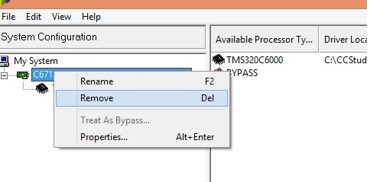

4. To add the processor to the My system:

In the 2nd column, a) Family - > C67xx, Platform -> simulator

b) Double click on C6713 device cycle accurate simulator

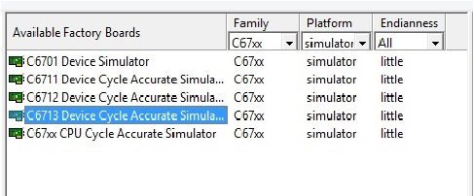

5. Click on save and quit (Left side down), then click -> Yes.

6. Project window will open. Click on Project -> New

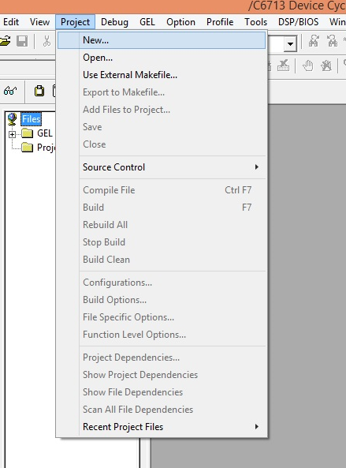

7. Project Creation (it creates folder)

Project name -> xyz (Any name)

Location -> C:\CCStudio_v3.1\MyProjects\

Target -> TMS320C67xx

then click on Finish

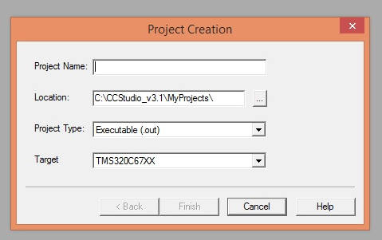

8. Under project, click on + mark and expand the project.

9. File -> New -> Source file

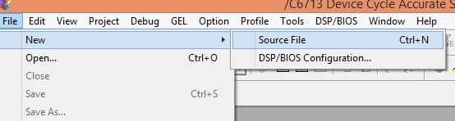

10. Save the file in your folder, save in -> Local disk (C) -> CCStudio_v3.1 -> MyProjects -> your project (xyz) -> with name and extension.c. For example: xyz.c

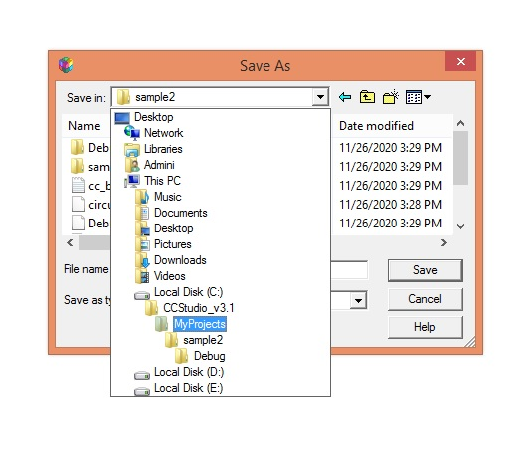

11. Add the saved file to your project by right click on Source -> Add files to project

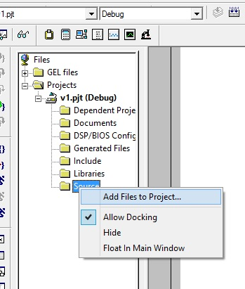

Browsing the file from your poject, Look in -> Local disk (C) -> CCStudio_v3.1 -> My Projects -> your project (xyz) -> File (xyz.c) -> open

12. To add the library file to the project right click on libraries-> add files to project

Look in -> Local disk (C) -> CCStudio_v3.1 -> C6000 -> cgtools -> lib -> rts6700, open

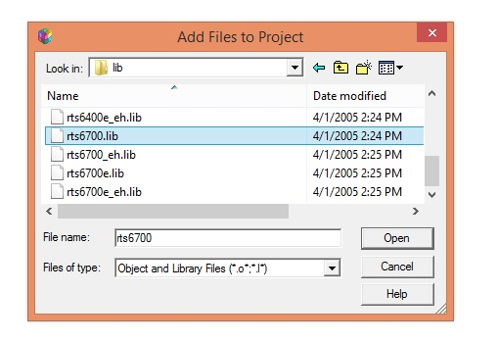

13. To add the command file to the project right click on source -> add files to project

Look in -> Local disk (C) -> CCStudio_v3.1 -> tutorial -> dsk6713 -> hello1 **(*File of type -> Linker Command file**) -> hello

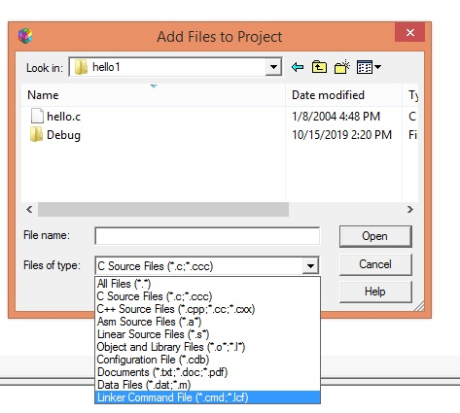

14. Type the program, then click on save

15. Build the program by clicking on Project -> Build Target, or Rebuild target

shortcut key is **F7**

16. File->load program. One pop up window will appear their open **Debug** folder -> Select your project name file with **.out** extension -> open

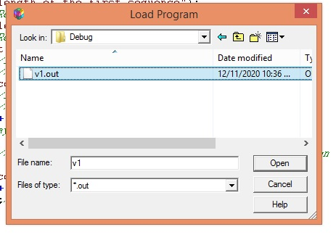

17. **Debug->Run**

Enter the sufficient values, if necessary

18. To check graph (common for all the Part-B experiment)

**View-> Graph -> Time/Frequency**

|  |  |
| --- | --- |
| **Start address** | **y (O\p Variable)** |
| **Display Data Size** | **8 (example: o/p count is 7 then 8)** |
| **Data Plot Style** | **Bar** |

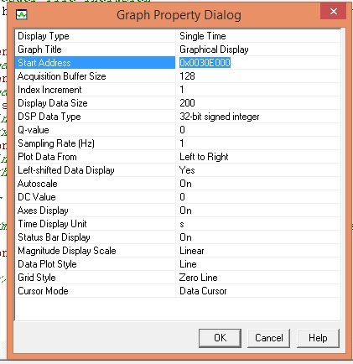

* **Only for N-Point Dft**

**View-> Graph -> Time/Frequency**

|  |  |
| --- | --- |
| **Display Type** | **Dual time** |
| **Interleaved data sources** | **Yes** |
| **Start address** | **y** |
| **Display Data Size** | **o/p count + 1** |
| **DSP Data Type** | **32 bit IEEE Floating point** |
| **Autoscale** | **Off** |
| **Maximum Y - value** | **15 or 20** |
| **Data Plot Style** | **Bar** |